Review of Hooke’s Law:
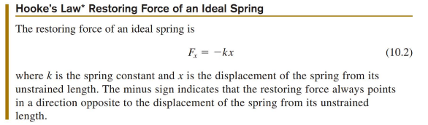
Question 1: How much force is needed to compress a spring with a spring constant of 150 N/m a distance of 20 cm?

Question 1: How much stretch of a spring is obtained if the pulling force is 30N? The spring constant is 150 N/m.

For springs connected in parallel, the effective spring constant is:
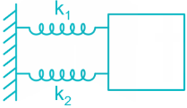 $K_{eff}=k_{1}+k_{2}$

For springs connected in series, the effective spring constant is:
 $\frac{1}{K_{eff}}={\frac{1}{k_{1}}}_{}+{\frac{1}{k_{2}}}_{}$, or: $K_{eff}={\frac{k_{1}⋅k_{2}}{k_{1}+k_{2}}}_{}$

Elastic Potential Energy: ${PE}_{s}=\frac{1}{2}kx^{2}$
where k is the spring constant, and x is actually $Δx$ ,the stretched or compressed length of the spring.

Simple Harmonic Motion
The oscillations of a system in which the net force can be described by Hooke’s law are of special importance, because they are very common. They are also the simplest oscillatory systems. Simple Harmonic Motion (SHM) is the name given to oscillatory motion for a system where the net force can be described by Hooke’s law, and such a system is called a simple harmonic oscillator.

Examples of simple harmonic motion: The spring-block system oscillating around its equilibrium position. The simple pendulum. A small marble goes up and down at the bottom of a smooth bowl
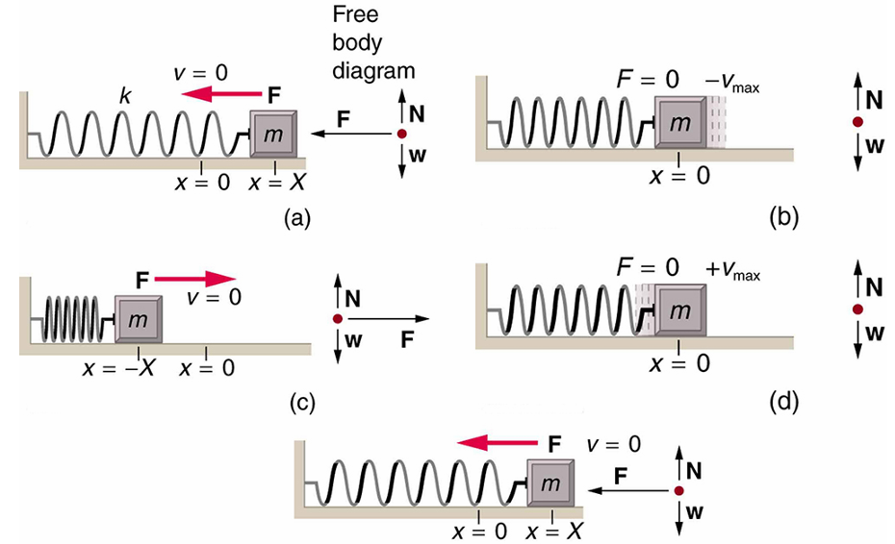
An object attached to a spring sliding on a frictionless surface performs a simple harmonic motion. When displaced from the equilibrium position at x=0, the object oscillates right-left-right with an amplitude X and a period T
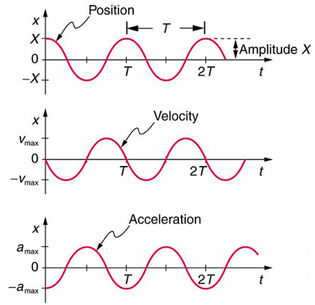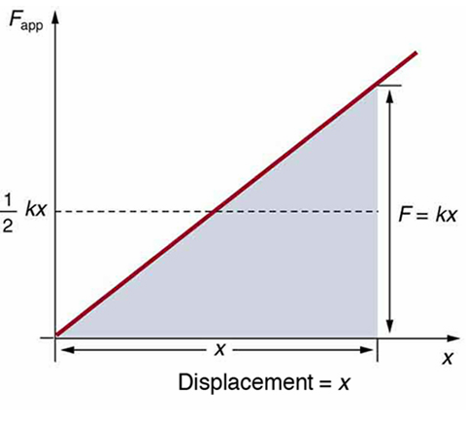
$x=Xcos(ωt), v=-Xωsin(ωt), a=-Xω^{2}cos(ωt)$ Spring force $F=kx$ is a changing force

Amplitude(A): Period(T): Frequency ( f ): Angular Frequency($ω$):

Period of a Simple Harmonic Oscillator
The period of a simple harmonic oscillator is: $T=2π\sqrt{\frac{m}{k}}$ , The frequency is: $f=\frac{1}{2π}\sqrt{\frac{k}{m}}$ ,
Where k is the spring constant, and m is the mass of the oscillator.
The period of a simple pendulum is: $T=2π\sqrt{\frac{l}{g}}$ , $l$ is the length of the string, g is the acceleration due to gravity

Example 1
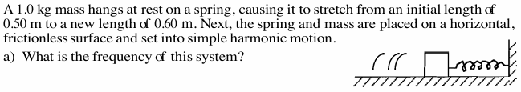
b) Find the period and amplitude of oscillation of this system?

d) What is the maximum elastic potential energy of this system?

e) What is the maximum speed of the block?

Example 2 A Pendulum has a string of 1.2 m long, mass of the pendulum bob is 25.6 g. What is the period of this pendulum? If the pendulum is taken to the moon, what is the period?

Example 3
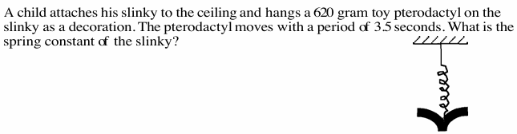

Position-time graph for Simple Harmonic Motion
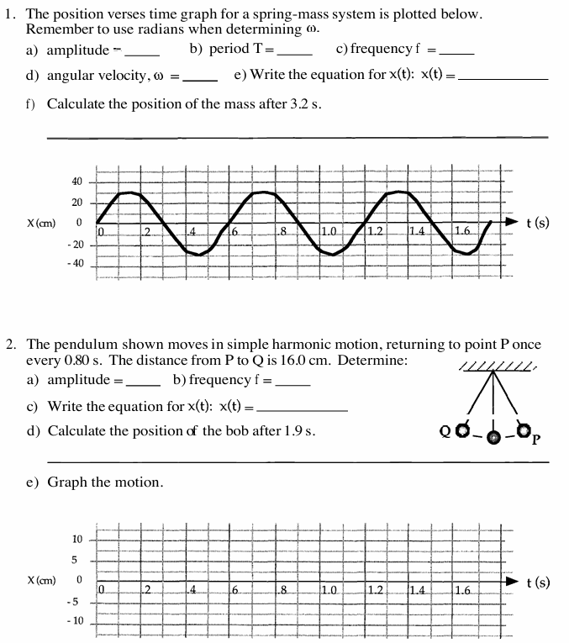

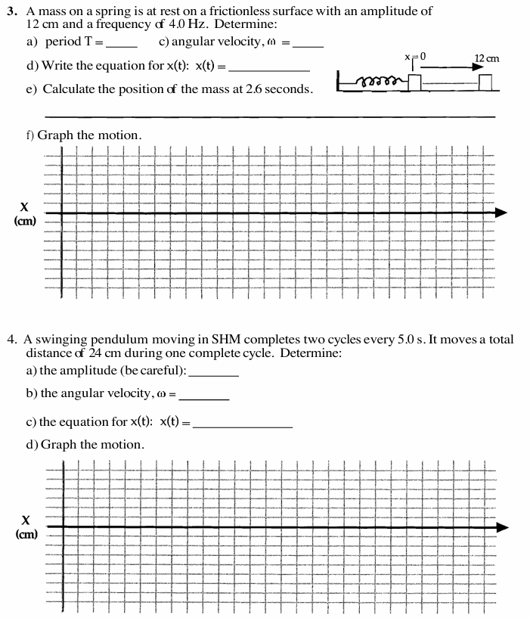

$K_{eff}=k_{1}+k_{2}$ (parallel) $\frac{1}{K_{eff}}={\frac{1}{k_{1}}}_{}+{\frac{1}{k_{2}}}_{}$, or: $K_{eff}={\frac{k_{1}⋅k_{2}}{k_{1}+k_{2}}}_{}$(Series)
Lab Hooke’s Law and Spring Constant
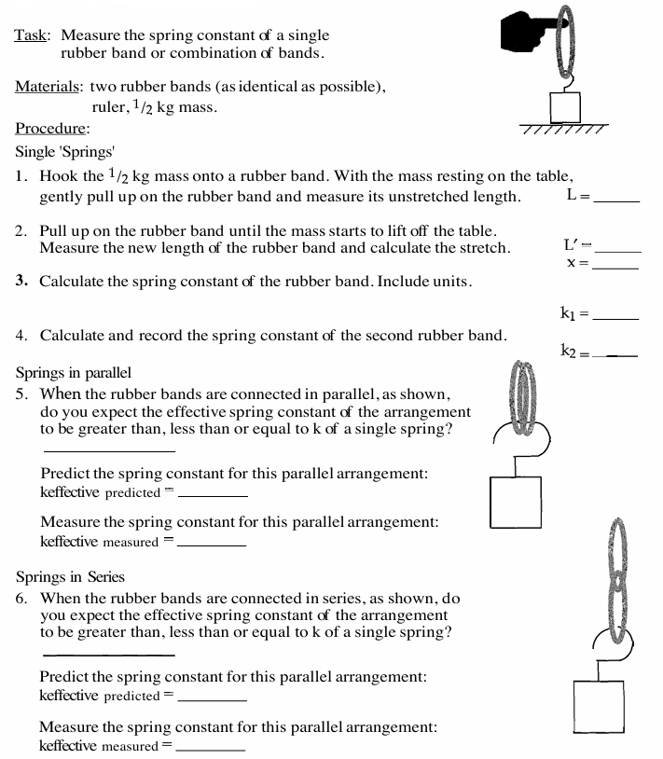

$K_{eff}=k_{1}+k_{2}$ (parallel) $\frac{1}{K_{eff}}={\frac{1}{k_{1}}}_{}+{\frac{1}{k_{2}}}_{}$, or: $K_{eff}={\frac{k_{1}⋅k_{2}}{k_{1}+k_{2}}}_{}$(Series)
Questions:
